**Hypothesis Testing**

**Problem Statement:** Aravind Productions (AP) is a newly formed movie production house based out of Mumbai, India. AP was interested in understanding the production cost required for producing a Bollywood movie. The industry believes that the production house will require at least INR 500 million (50 crore) on average. It is assumed that the Bollywood movie production cost follows a normal distribution. Production costs of 40 Bollywood movies in millions of rupees are given in the Table. Conduct an appropriate hypothesis test at ɑ=0.05 to check whether the belief about average production cost is correct.

**Table:** Production cost of Bollywood movies(million INR)

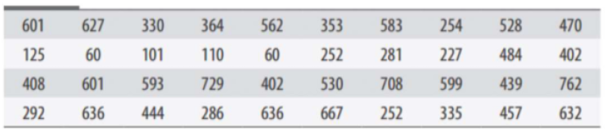

**Solution:**

**Industry belief:** The production house will require at least INR 500 million(50 crore) on average.

**Assumption:** Bollywood movie production cost follows a normal distribution.

The null hypothesis ($H_{0}$): (*μ* = 500 million)

The alternative hypothesis ($H_{1}$): (*μ*＞500 million)

Here, the standard deviation of the sample is not given hence T-test is used for testing the hypothesis.

Calculate the mean and standard deviation of the sample:

$$n=40, \overline{X}=429.55, σ=195.0337,$$

$$t-statistic=\frac{\overline{X}-μ}{ \frac{σ}{\sqrt{n}}}=\frac{429.55-500}{\frac{195.0337}{\sqrt{40}}}=-2.2845$$

Calculate the p-value:

Degree of freedom(n-1) = 39

t-critical = 1.6848 [computed using Excel by inserting the formula, T.INV(0.05, 39)]

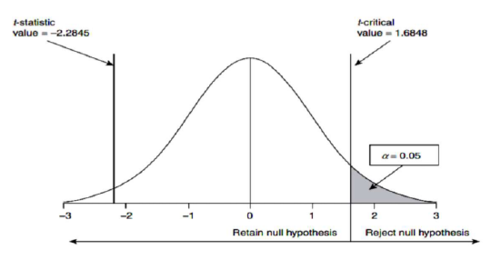

t-statistic ＜t-critical

Fail to reject the null hypothesis.

**Problem Statement:** You are planning the campaign of the Chief Minister of a major state going to election in a month’s time. You want to figure out the effectiveness of a 10 sec YouTube ad in increasing the popularity of the CM’s party in a particular region. If a person clicks on the ad, then that ad is effective in drawing attention. Assume that

YouTube can deliver ads to a particular location and that “Skip Ad” is disabled as the video is only 10 sec. Currently, Ad A is running in both regions. You propose to use Ad B. So, you isolate 2 hours for running a test (Serve Ad A for 1 hour and Serve Ad B for 1 hour), and obtain the following data:

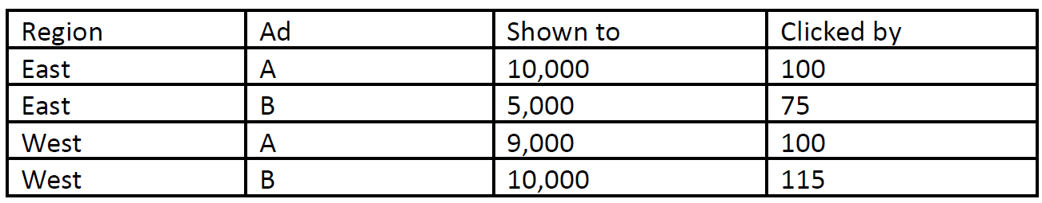

1.Estimate, statistically at 1% significance, if Ad B is preferred in the East region.

**Solution:**

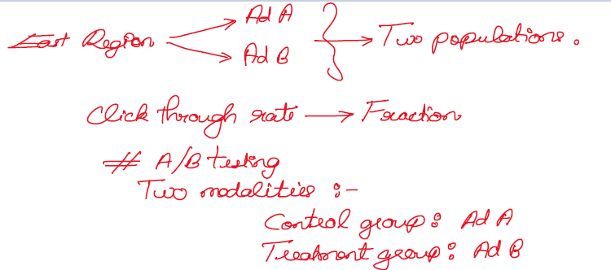

**Steps:**

1. Formulating Hypothesis
2. Define test statistic
3. Calculate the p-value
4. Compare against a threshold value

Step 1: Formulating the hypothesis

Null hypothesis ($H_{0}$): There is no difference between the control and treatment group.

$P_{a}$ = $P_{b}=P$

Alternative hypothesis ($H_{1}$): There is a real effect to the treatment.

$P_{b}$ ＞ $P_{a}$

Step 2: Set the test statistic

$$Z_{obs}=\frac{\hat{p_{B}}-\hat{p_{A}}}{{SE}_{0_{\left(\hat{p_{B}}-\hat{p_{A}}\right)}}}$$

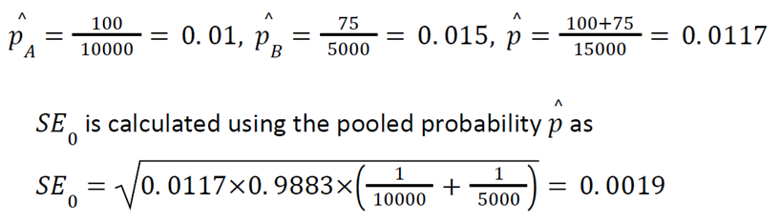

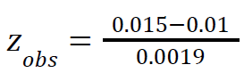

$$Z_{obs}=2.63$$

Step 3: Calculate the p-value



Step 4: Compare against a threshold

P-Value is less than the threshold of 0.01. Hence, there evidence against the null hypothesis.

We reject the null hypothesis and conclude that there is a statistically significant preference for Ad B in East Region.

2. Repeat the same for west region and combined state.